**Contents**

Laboratory Rules 1

Writing Up Your Lab Report 2

Marking Scheme 3

1st Semester Experiments

Experiment 1. Newton's Second Law 4

Experiment 2. Archimedes' Principle 10

Experiment 3. Acceleration Due To Gravity 15

Experiment 4. Young's Modulus 19

Experiment 5. Simple Harmonic Motion 25

Appendix

Appendix 1. Significant Figures 29

Appendix 2. Graphs 31

Appendix 3. Uncertainties / Errors 33

Appendix 4. The Vernier Calipers 37

Appendix 5. The Micrometre Screw Gauge 39

## Laboratory Rules

The safety of everyone working in the undergraduate laboratories is of prime importance and your co-operation in this matter is obligatory. Laboratories are potentially dangerous environments but the dangers can be minimized and safety ensured if all working there behave in a mature and responsible manner.

1. Attendance is mandatory. If you cannot attend a laboratory session, you should notify the year course coordinator / Lab Supervisor - if possible in advance, otherwise as quickly as possible afterwards.

2. You are not allowed to leave the laboratory without showing your final results and analysis to your demonstrator. At the end of the session you should leave your bench tidy for the next user. Switch off and disconnect all apparatus.

3. If your partner is absent you have to do the experiment on your own or speak to demonstrator.

4. Stick to assigned timetable.

5. Strictly no eating, drinking, or smoking in the laboratory, but you are allowed to take a brief break during the laboratory session.

* Every student is expected and required to respect the rights of fellow students and the authority of the University academic and other staff in the performance of their duties.
* Every student is expected and required to observe the rules and regulations of the University.
* Every student is expected and required to conduct themselves in a manner conducive to the academic environment of the University and the promotion of its objectives.
* Plagiarism is the representation of another person’s work as one’s own, and includes unacknowledged use of material from books or periodicals, from the internet, from teachers and tutors, or from other students, without full acknowledgement of the sources.

## Writing Up Your Lab Report

**1. Preparation for each Practical Session.**

Read the laboratory manual and consult the recommended texts before coming to the laboratory. Make notes and bring those with you.

**2. Practical Report.**

The following topics should be covered in the report.

* Date, Student number, Name, Title, and Aim.
* Brief overview and context of the experiment and main related theory. (Show you understand what ideas are being tested and how it is done and what you expect to show)
* Tables of Results - the results of your experiments should be recorded in ink immediately they are made. The laboratory manual suggests how the tables of results might be laid out. Give yourself plenty of room in the layout.
* Clarity is very important. If you have cause to re-measure a certain quantity, record this fact below the table of results. Record the ‘experimental uncertainties’ as you enter each item on the table.
* Any relevant graphs should be drawn on the graph paper in the report using pencil.
* Calculations - give the relevant formula and show how you arrived at your answer. Do not hold on to unjustifiable decimal places in your results. Use scientific notation e.g. write 7.43×10-3 instead of 0.00743. Conclusions (not more than 100 words)- Summaries the aim and method of the experiment. State your main results. Comment on how your results compare with the expected values and explain any discrepancies.

**Sample Conclusions: (1. Newton's Second Law)**

A horizontal air track apparatus was used to measure the acceleration of a mass of 450 grams in response to an applied force. The applied force was due to gravity acting on part of the 450 grams. We have found that the acceleration of the mass is indeed proportional to the applied force and that the slope of a graph of force versus acceleration gave a straight line with slope 0.440 kg. This is close to the expected value of 450 grams, and in reasonable agreement with Newton’s Second Law.

## Marking Scheme

All experiments are graded out of 10 (no half marks).

The following is a guide to how marks are awarded. There is flexibility between experiments as not all experiments can be equally assessed e.g. in terms of error analysis.

Marks are given for:

* Presentation of Results.
* Calculations.
* Uncertainty Analysis.
* Methods / Precautions.
* Apparatus / Diagrams.
* Conclusions.
* Questions.

**Guide to marks for Laboratory reports.**

0 - Nothing written in laboratory report.

1 - Bare minimum (e.g. diagram of apparatus); no results, no calculations.

3 - Description plus some results, but nothing else.

4 - Reasonable description and results, but no calculations or discussion (or results are clearly wrong, with no understanding illustrated).

5 - Description, results, brief discussion, but no error analysis (or incorrect errors, and perhaps some mistakes in calculations).

6 - Reasonably complete report, with some error analysis (may not be fully correct).

7 - Good report with correct error analysis and some relevant discussion of results.

8 - As 7 with good discussion - clear indication of full understanding.

9 - Excellent report in most aspects, with one or two reservations.

10 - Excellent report in all aspects.

## Experiment 1. Newton's Second Law

**1. Aim:**

To verify Newton’s Second Law of motion.

**2. Theory:(** **Read: Cutnell and Johnson – Chapter 4.3)**

When a net external force ***F*** is applied to an object of mass *m*, the acceleration ***a*** that results is directly proportional to the net force and has a magnitude that is inversely proportional to the mass. The direction of the acceleration is the same as the direction of the net force. ***F*** and ***a*** are vector quantities, while ***m*** is a scalar quantity.

(1)

In SI units, ***F*** is measured in newtons (N), ***a*** is measured in metres per second squared (m/s2) and *m* is measured in kilograms (kg).

Often, several forces act on an object simultaneously. Friction and wind resistance, for instance, do have some effect on a hockey puck. In such cases, it is the net force, or the vector sum of all the forces acting, that is important. Mathematically, the net force is written as **Σ*F***, where the Greek capital letter **Σ** (sigma) denotes the vector sum. Newton’s second law states that the acceleration is proportional to the net force acting on the object. Note that the net force in Equation (1) includes only the forces that the environment exerts on the object of interest. Such forces are called external forces. In contrast, internal forces are forces that one part of an object exerts on another part of the object and are not included in Equation (1).

In Newton’s second law, the net force is only one of two factors that determine the acceleration. The other is the inertia or mass of the object. After all, the same net force that imparts an appreciable acceleration to a hockey puck (small mass) will impart very little acceleration to a semitrailer truck (large mass). Newton’s second law states that for a given net force, the magnitude of the acceleration is inversely proportional to the mass. Twice the mass means one-half the acceleration, if the same net force acts on both objects. Thus, the second law shows how the acceleration depends on both the net force and the mass, as given in Equation (1).

When using the second law to calculate the acceleration, it is necessary to determine the net force that acts on the object. In this determination a ***free-body diagram*** helps enormously. A free-body diagram is a diagram that represents the object and the forces that act on it. Only the forces that act on the object appear in a free-body diagram. Forces that the object exerts on its environment are not included. Fig. 1 illustrates the use of a free-body diagram.

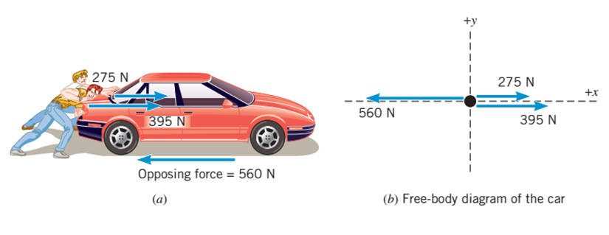

Fig. 1 (a) Two people push a stalled car. A force created by friction and the pavement opposes their efforts. (b) A free-body diagram that shows the horizontal forces acting on the car.

According to Newton’s second law, the acceleration is the net force divided by the mass of the car. To determine the net force, we use the free-body diagram in Fig. 1. In this diagram, the car is represented as a dot, and its motion is along the *x* axis. The diagram makes it clear that the forces all act along one direction. Therefore, they can be added as collinear vectors to obtain the net force.

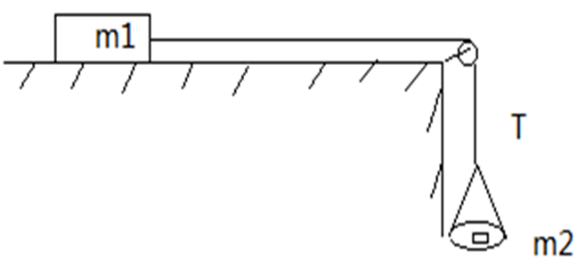

Fig. 2 The free-body diagram of the system in the experiment.

Using the free-body diagram in Fig. 2, we can obtain:

(2)

 (3)

By combining Equation (2) and (3), the following equation can be written as

 (4)

Then, we define:

 (5)

Newton’s second law of motion can be expressed as .

**3. Procedure:**

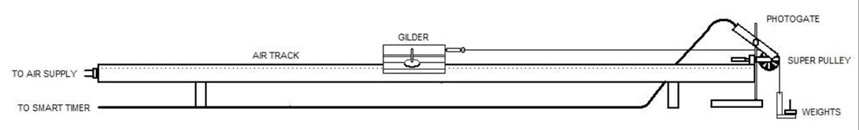

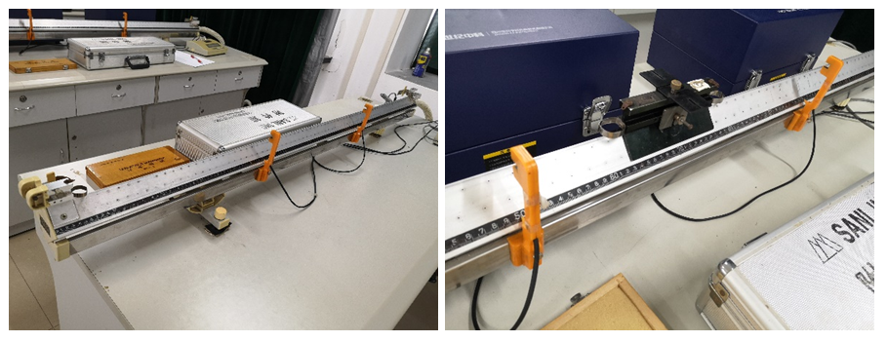

Fig.2 The instrument structure.

(a) The air-track arrangement is similar to that shown above. Unhook the Mass Holder from the Glider and level the track carefully by tuning the adjustable feet. With the air-blower turned on, the Glider will sit on a level track without moving in either direction. (Coarse Adjustment)

(b) Install two photogates on the air track, and the distance between two photogates should be approximately 50 cm. Turn on the Smart Timer and set it to *1pr*. Start fine tuning. ( and (*t*2 - *t*1) / *t*1 ≤ 3%)

(c) Transfer 25 grams from the weight box onto the Mass Holder. Record the mass of the Mass Holder and the added mass as ma. The gravitational force, due to ma, causes the glider to be accelerated. This acceleration can be measured electronically by using the Smart Timer.

(d) Turn on the Smart Timer with two photogates connected to plug 1 and 2 on the Smart Timer. Set the Smart Timer to *2pr*. After pressing the *Execute* button, the timer is ready for a measurement. (The distance between two photogates should be approximately 50 cm, while the initial positions of the Glider should keep the same in multiple measurements)

(e) Pull the Glider approximately 120 cm from the pulley with allowing the mass holder to hang up to about 20 cm below the pulley. Turn on the air supply. When the Glider is in place with the air supply on, the Execute button can be pressed and the Glider will be released. Press the Execute button and simultaneously release the glider so that it runs the track for an accurate result.

(f) Record the figure on the screen of the Smart Timer due to the combined mass of the added object and the Mass Holder. Repeat this measurement five times until a consistent set of results is obtained with making sure that the Total Mass of the system remains constant.

(g) The Glider does not need to travel the length of the whole track to take the reading and should be stopped manually once a figure appears on the screen or before hitting the damper at the pulley. (Ensure that the laser photogate is accurately being interrupted by the metal plate fixed on the Glider)

(h) Measure the width of the metal plate fixed on the Glider for triggering the photogates by using a Vernier caliper. Weigh the Mass Holder, the Glider and the added masses and record this as MT., the total mass of the system. The table below should be copied into your lab report and used to record your results. The value of the acceleration due to gravity is g = 9.79 m/s2.

Draw the following results table in your report.

Mass transferred from the Glider to the Mass Holder

|  |  |  |  |  |  |  |
| --- | --- | --- | --- | --- | --- | --- |
| Δ*L*= mm  *x*2*-x*1*=* m | Run number | Δ*t*1 (ms) | Δ*t*2 (ms) | *v*1 (m/s) | *v*2 (m/s) | Acceleration  ***a*** (m/s2) |
| 25 grams | 1 |  |  |  |  |  |
| 2 |  |  |
| 3 |  |  |
| Average |  |  |
| 20 grams | 1 |  |  |  |  |  |
| 2 |  |  |
| 3 |  |  |
| Average |  |  |
| 15 grams | 1 |  |  |  |  |  |
| 2 |  |  |
| 3 |  |  |
| Average |  |  |
| 10 grams | 1 |  |  |  |  |  |
| 2 |  |  |
| 3 |  |  |
| Average |  |  |
| 5 grams | 1 |  |  |  |  |  |
| 2 |  |  |
| 3 |  |  |
| Average |  |  |

The velocities when the Glider passes through the two photogates can be calculated by:

*v* =

Δ*L* is the width of the metal plate fixed on the Glider for triggering the photogates, Δ*t* is the time interval recorded by the Smart Timer.

The acceleration can be calculated by the following equation:



Here, v1 and v2 denote the velocities the Glider passes through the two photogates, and x2 - x1 is the distance between the two photogates.

Transfer another 5 g from the Mass Holder to the Glider and repeat the measurements taken above. Continue to transfer 5 g masses from the Mass Holder to the Glider until you have measured the average acceleration caused by having a 25 g, 20 g, 15 g, 10 g, 5 g on the Mass Holder.

MT – Total system mass = ________ (kg)

|  |  |  |
| --- | --- | --- |
| Total mass of Mass Holder & added masses  ***m*a**(kg) | Average acceleration caused by the total mass recorded in column 1.  ***a***(m/s2) | Gravitational force due to total mass recorded in column 1.  ***Fa*** = ma × 9.79 N |
|  |  |  |
|  |  |  |
|  |  |  |
|  |  |  |
|  |  |  |

**4. Results:**

Draw a graph of the applied force, ***Fa***, versus the average acceleration ***a*** of the whole system (Glider plus added masses plus Mass Holder), i.e. plot ***Fa*** on the *y* axis and ***a*** on the *x* axis.

Since Newton’s Second Law states that the acceleration is proportional to the applied force, i.e., ***F*** = m***a*,** your data points should lie on a straight line.

Measure the slope of your graph and compare your measured slope to the expected value, which is the total mass of the system, ***MT***.

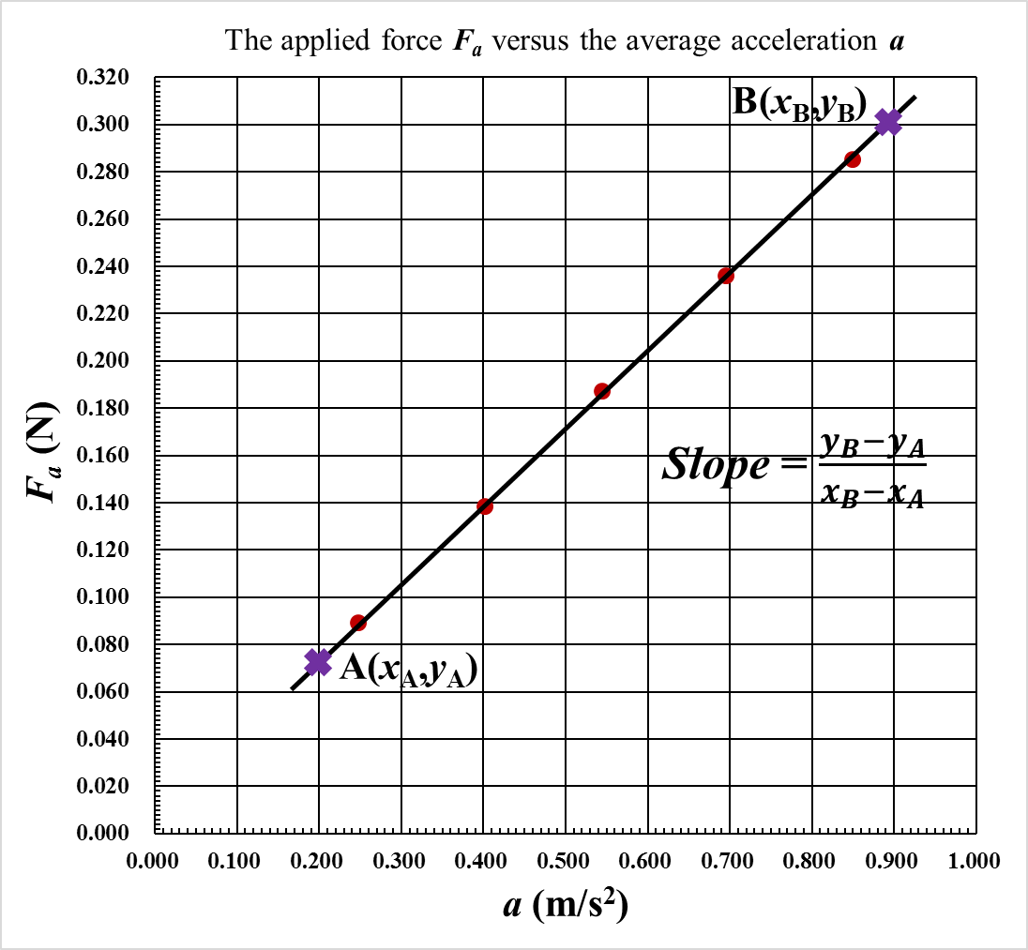

**5. Conclusions:**

In no more than 100 words write a succinct summary of what you have done. State the goal and method of the experiment. State your main results, i.e., Did you find that the acceleration is proportional to the applied force, or not? What value did you get for the constant of proportionality? Are your results consistent with Newton’s Second Law? If your results are not consistent with Newton’s Second Law, can you suggest why not?

## Experiment 2. Archimedes' Principle

**1. Aim:**

The determination of the density of water, steel and brass using Archimedes’ Principle.

**2. Theory: (** **Read: Cutnell and Johnson – Chapter 11.6)**

When an object is partially or completely immersed in a liquid it experiences an upward force (upthrust) equal to the weight of the liquid displaced. Let ***ρ*** be the density of the liquid, ***V*** the volume of the object under the liquid surface and g the acceleration due to gravity - the upward force or ‘upthrust’ ***F***is given by;



For a cylindrical object, the submerged volume is equal to the cross-sectional area, A, multiplied by the submerged height, ***h***. So the upthrust can be written as:



If an object is weighed in air and then weighed while submerged in a liquid, the object will show an apparent loss in weight. An alternative statement of Archimedes’ Principle to the one given above is that the:

**Apparent Loss in Weight = Weight of Liquid Displaced**

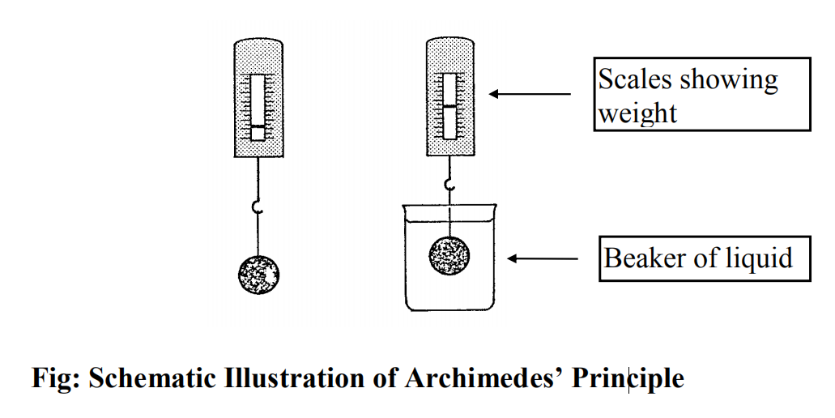

Fig.1 Schematic Illustration of Archimedes’ Principle.

**3. Procedure:**

PART 1 – Density of water.

(a) The equipment is set up as shown. Fill the 1 litre beaker to within 5 cm of the top. Use the metal cylinder with a Hanging point in the first part of this experiment. There are lines 1cm apart etched on the side of the cylinder.

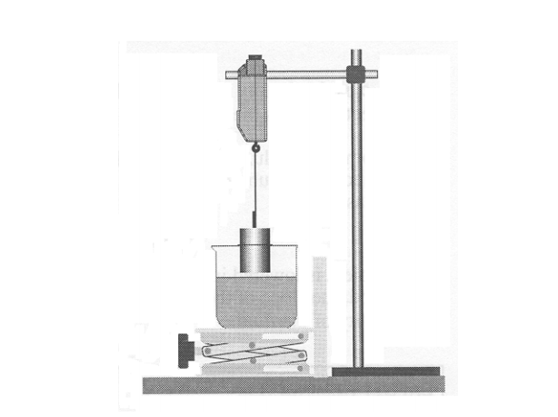

Fig.2 The instrument structure.

(b) Use the Vernier Calipers to measure the diameter of the cylinder. Take a number of readings at five different places along the cylinder and work out the mean diameter. Calculate the cross-sectional area (). Record all readings and calculations in your laboratory notebook.

Table of Results 1：

|  |  |  |  |  |  |
| --- | --- | --- | --- | --- | --- |
| Diameter of Cylinder (mm) | | | | | |
| Reading 1 | Reading 2 | Reading 3 | Reading 4 | Reading 5 | Reading 6 |
|  |  |  |  |  |  |
| Total 1-6 (mm) | | |  | | |
| Mean Diameter (mm) | | |  | | |
| Cross-sectional Area (m2) | | |  | | |

(c) Use the lab jack to raise the beaker until the lowest mark on the side of the cylinder is level with the surface of the water.

(d) Read the scale on the force sensor and record the force (i.e. the weight of the cylinder) at minimum (assume as zero)immersion.

*It may be necessary to check that the force meter is properly calibrated before beginning the experiment. This can be achieved by pulling and releasing the hook . If the pointer is not level vith the zero scale as it should be the force meter can be recalibrated by pulling the scale meter.*

(e) Raise the lab jack until the next mark on the side of the cylinder is level with the surface of the water. After five or ten seconds, to allow the system to stabilize, record the force at 1 cm plus immersion.

(f) Increase the depth of immersion by steps of 1 cm and record the force at each depth.

**Health and Safety: Clean up any spillages of water immediately.**

Table of Results 2a:

|  |  |  |  |  |  |  |  |
| --- | --- | --- | --- | --- | --- | --- | --- |
| Depth (m) | 0 | 0.0100 | 0.0200 | 0.0300 | 0.0400 | 0.0500 | 0.600 |
| Force (N) |  |  |  |  |  |  |  |

Table of Results 2b:

|  |  |  |  |  |  |
| --- | --- | --- | --- | --- | --- |
| Slope Data And Density | | | | | |
|  | Depth(m) | Force(N) |  | Depth(m) | Force(N) |
| Point A  coordinate value |  |  | Point B coordinate value |  |  |
| Best-fit  () | | |  | | |
| （） | | |  | | |

PART 2 – Density of metal.

The density of an object is its mass divided by its volume. Carry out an experiment to measure the density of the two metallic cylinders by weighing them in air and measuring their volume.

(a) Measure diameter of the cylinder.

Table of Results 3：

|  |  |  |  |  |  |
| --- | --- | --- | --- | --- | --- |
| Diameter of Cylinder (mm) | | | | | |
| Reading 1 | Reading 2 | Reading 3 | Reading 4 | Reading 5 | Reading 6 |
|  |  |  |  |  |  |
| Total 1-6 (mm) | | |  | | |
| Mean Diameter (mm) | | |  | | |
| Cross-sectional Area (m2) | | |  | | |

(b) Measure height of the cylinder.

Table of Results 4：

|  |  |  |  |  |  |
| --- | --- | --- | --- | --- | --- |
| Height of Cylinder (mm) | | | | | |
| Reading 1 | Reading 2 | Reading 3 | Reading 4 | Reading 5 | Reading 6 |
|  |  |  |  |  |  |
| Total 1-6 (mm) | | |  | | |
| Mean height (m) | | |  | | |

(c) Measure mass of the cylinder.

Table of Results 5：

|  |  |  |  |
| --- | --- | --- | --- |
|  | Mass (kg) | Volume() | Density () |
| Metal 1 |  |  |  |
| Metal 2 |  |  |  |

**By comparing the densities you have measured with those listed in the Tables of Physical and Chemical Constants, try to identify the two metals.**

**4. Results:**

(a). Plot a graph of force versus depth of immersion.

(b). Measure the slope of your graph. Choose two points from the graph, read their coordinate values, then calculate the slope of graph.

(c). From Archimedes’ Principle F = (ρAg)h so the slope of the line is given by



Where ***ρ***is the density of the liquid, *A* is the cross-sectional area of the cylinder and ***g***is the acceleration due to gravity, ***g*** = 9.79 m/s2. Use this formula to estimate the density of water. Look up the accepted value in Tables of Physical and Chemical Constants, by Kaye and Lab.

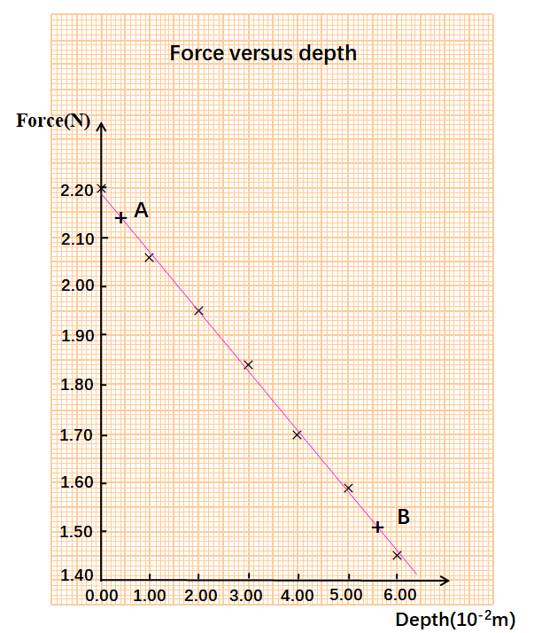

**5. Conclusions:**

In no more than 100 words write a succinct summary of what you have done. State the goal and method of the experiment. State your main results, i.e.: What value did you get for the the density of the liquid? Is your result in agreement with the water value? What is the density of the metal cylinder you measured? What metal do you think it is? Why is this judged?

## Experiment 3. Acceleration Due To Gravity

**1. Aim:**

To measure *‘****g***’, the acceleration due to gravity using a simple pendulum.

**2. Theory: (** **Read: Cutnell and Johnson – Chapter 10.4)**

A simple pendulum consists of a particle of mass *m*, attached to a frictionless pivot P by a cable of length *L* and negligible mass. When the particle is pulled away from its equilibrium position by an angle ***θ*** and released, it swings back and forth as Fig. 1 shows. By attaching a pen to the bottom of the swinging particle and moving a strip of paper beneath it at a steady rate, we can record the position of the particle as time passes. The graphical record reveals a pattern that is similar (but not identical) to the sinusoidal pattern for simple harmonic motion.

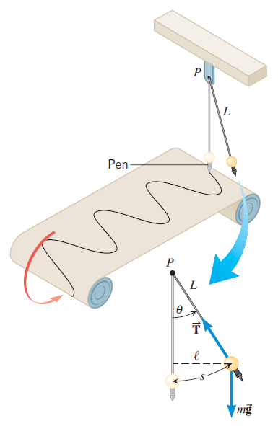

Fig. 1 A simple pendulum swinging back and forth about the pivot *P*. If the angle *θ* is small, the swinging is approximately simple harmonic motion.

Gravity causes the back-and-forth rotation about the axis at P. The rotation speeds up as the particle approaches the lowest point and slows down on the upward part of the swing. Eventually the angular speed is reduced to zero, and the particle swings back. If the angle of oscillation is large, the pendulum does not exhibit simple harmonic motion. The motion of a simple pendulum is nearly simple harmonic. The periodic time ***T*** is related to the length ***L*** of the pendulum and the local acceleration due to gravity ***g***.

 or 

If we measure the periodic time *T* for different lengths L, and plot ***T2*** versus ***L***, we should get a straight line that passes through the origin. The graph will have slope. Thus, by measuring the slope of the graph we can determine ***g***.

**3. Procedure:**

(a) Tie a thread to a pendulum bob. Pass the other end of the thread through the hole of the fixed device on the retort stand. And adjust the pendulum overhangs the graduated scale. The length of the pendulum is adjusted by the regulating screw on the fixed device and fixed by the locking screw on it.

(b) Place a graduated scale with several vertical marks on it under the pendulum, so that when the latter is at rest, it aims one of the vertical marks from an observer in front of the pendulum.

(c) Set the pendulum bob swinging through a small arc by using the large protractor as a guide. Check that the swing is in a vertical plane. Restart the bob if the swing is elliptical. A ‘small’ arc means less than 5○ or that the amplitude of swing is always less than one tenth of the length of the pendulum being used.

(d) Choose five lengths (e.g. 0.45, 0.50, 0.55, 0.60 and 0.65 m are satisfactory). It is not necessary to adjust the lengths to those exact values. The length used should however be measured accurately - measure from the lower face of the hole of the fixed device to the centre of the bob.

(e) For each length, make three determinations of the time required for 50 complete swings. Count ‘0’ as the bob passes the vertical marker and ‘1, 2, 3 etc.’ as the bob passes the marker again while going in the same direction. Average these three time values and calculate the time (periodic time) for one complete swing (oscillation). Tabulate the results in your report.

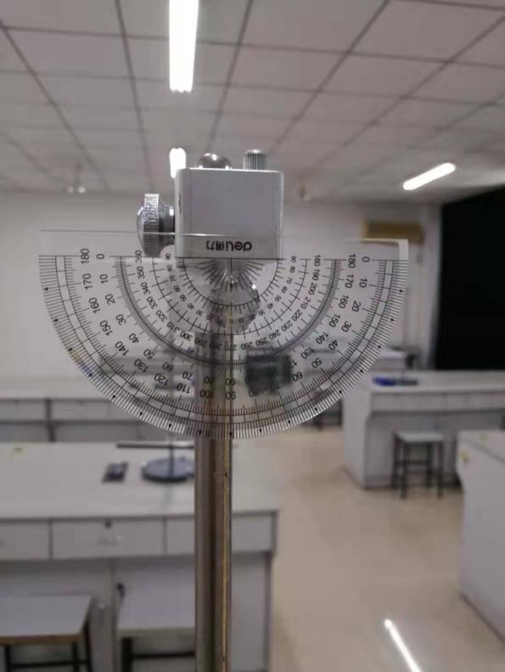 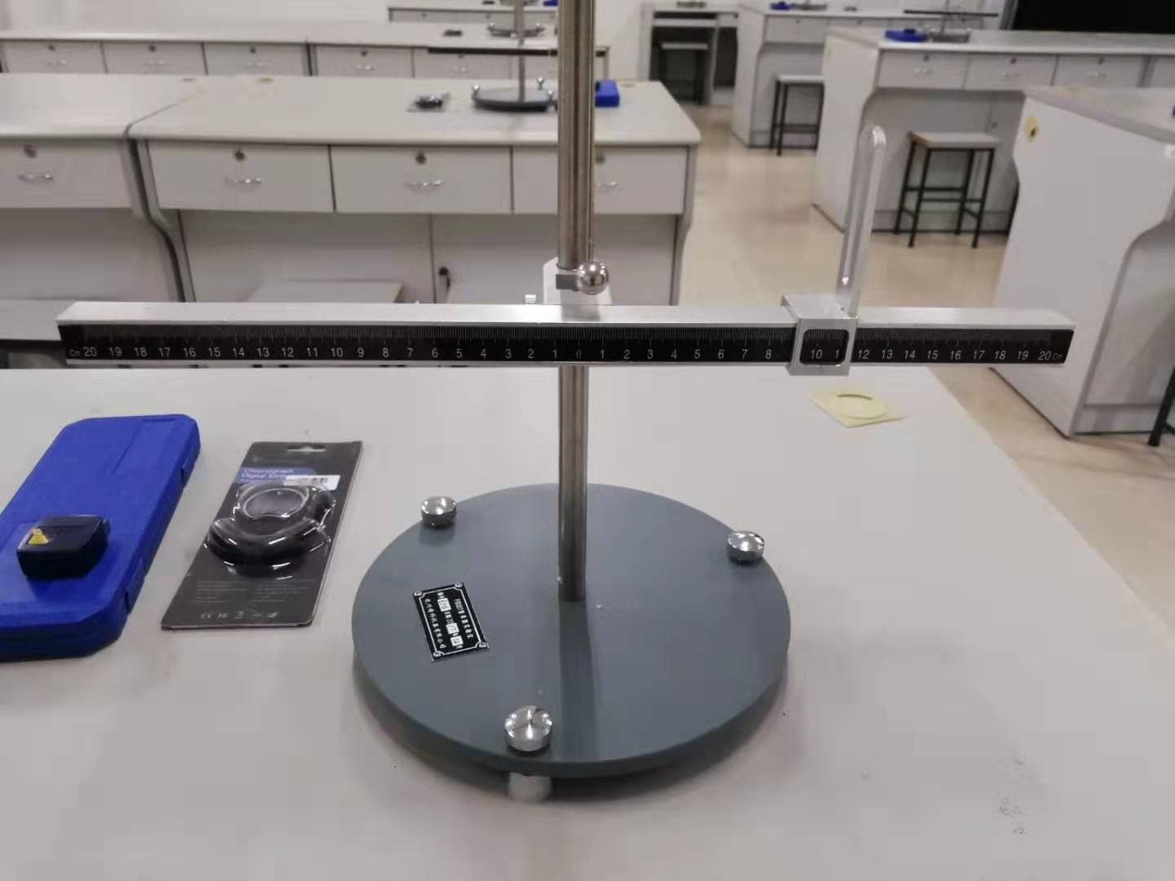

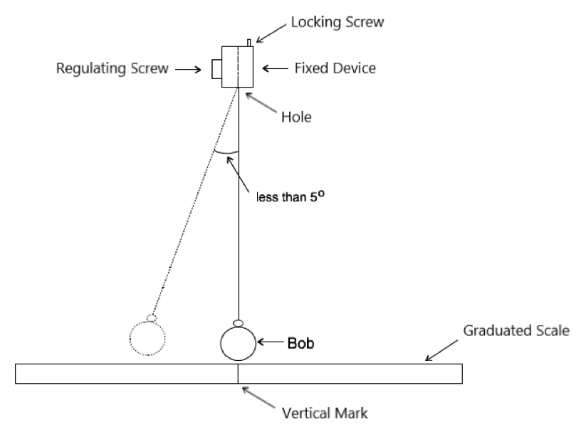

Fig. 2 The instrument structure.

|  |  |  |  |  |  |  |  |  |
| --- | --- | --- | --- | --- | --- | --- | --- | --- |
| TABLE OF RESULTS | | | | | | | | |
| Radius  *R*(mm) | Thread Length  *l* (m) | [Pendulum](javascript:;) Length  *L* (m) | Time for 50 Oscillations (s) | | | | Periodic Time  *T* (s) | *T*2 (s2) |
| 1stRun | 2ndRun | 3rdRun | Average |
|  |  |  |  |  |  |  |  |  |
|  |  |  |  |  |  |  |  |
|  |  |  |  |  |  |  |  |
|  |  |  |  |  |  |  |  |
|  |  |  |  |  |  |  |  |

**4. Results:**

Plot *T2* as a function of *L*. Obtain an average value of  from the slope of the graph. When drawing the graph ensure that the points are evenly spread on both sides of the line.

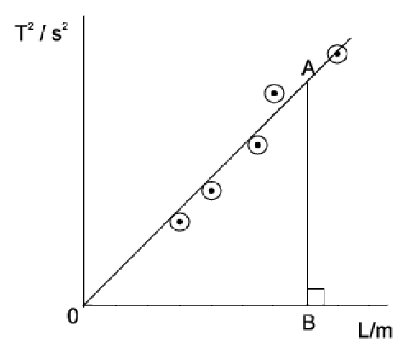

Fig. 3 How to get the slope.

A is any point on the graph and AB is perpendicular to the *L* axis.



**Calculate** ‘***g***’ from:



The value of g on the Earth's surface varies from point to point because of several effects:

(a) The Earth is not spherical (it is more closely an oblate spheroid);

(b) The Earth is rotating;

(c) The distribution of mass density in the Earth is not homogeneous;

(d) The Moon and Sun exert tidal accelerations;

(e) etc., etc...

The nominal value of g on a smooth Earth, taking into account oblateness and rotation is, at sea level :



Where *ϕ* is the latitude of the location. The latitude of FUZHOU UNIVERSITY is approximately .

Use this information to calculate the value of g at FUZHOU UNIVERSITY, and compare this calculated figure with the value you have measured.

**5. Conclusions:**

In no more than 100 words write a succinct summary of what you have done. State the goal and method of the experiment. State your main results, i.e.: What value did you get for the acceleration due to gravity? Is your result in agreement with the accepted value? If your result is not consistent with the accepted value can you suggest why not?

## Experiment 4. Young's Modulus

**1. Aim:**

(a) To estimate Young’s Modulus for a steel wire.

(b) To learn how to measure a tiny deformation.

**2. Theory: (** **Read: Cutnell and Johnson – Chapter 10.7)**

Solid bodies deform when a load is applied. If the material is elastic, the body returns to its original shape after the load is removed. Young's modulus is a measure of the stiffness of the elastic material and a quantity used to characterize materials. In Fig. 1, the length of a tested wire is ***L*0**, and ***F*** is the magnitude of the force applied perpendicularly to the area *A* of the wire. The strain or the unit deformation, is then represented by the dimensionless quantity ***ΔL*/*L*0**, here ***L*0** represents the initial length of the wire, and ***ΔL*** represents the stretch produced by the force ***F***.

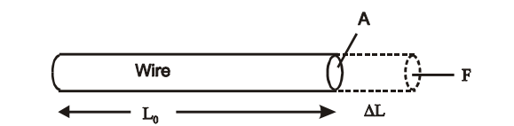

Fig. 1 A stress *F*/*A* on a wire leading to a strain Δ*L*/*L*0

The stress is proportional to the strain before a permanent deformation for the specimen occurs, and the constant of the proportionality is called the elastic modulus. Young's modulus is represented by the symbol ***E***. Hence, we have the equation

 (1)

or

 (2)

Once the stress, ***F*/*A***, and strain, ***ΔL*/*L*0**, are measured by the equipment in our lab, the Young's modulus, ***E***, can be determined for a specific sample in the lab. Now the problem is focused on how to determine the value **Δ*L***, a very tiny value after the sample is stretched because of the elasticity.

An optical lever is a convenient device to magnify a small displacement and thus to make an accurate measurement of the displacement. Fig. 2 shows an optical lever device to be used for measuring the tiny change **Δ*L*** of the wire. This device is seen as a detail on the left side of Fig. 2. The optical lever with a mirror rides on a small platform, two legs n2, and n3, of it stay in the groove of the platform while one leg n1 rides on the chuck that moves freely through the yoke. The chuck clamped to the lower end of the tested wire is just through the hole of it. Once the tested wire is stretched by a weight the mirror consequently tilted up also, as a result the reading of the ruler viewed from the telescope is changed as follows. The changes of the reading is proportional to the strain of the stretched wire. A detailed description of the principle is shown in Fig. 3.

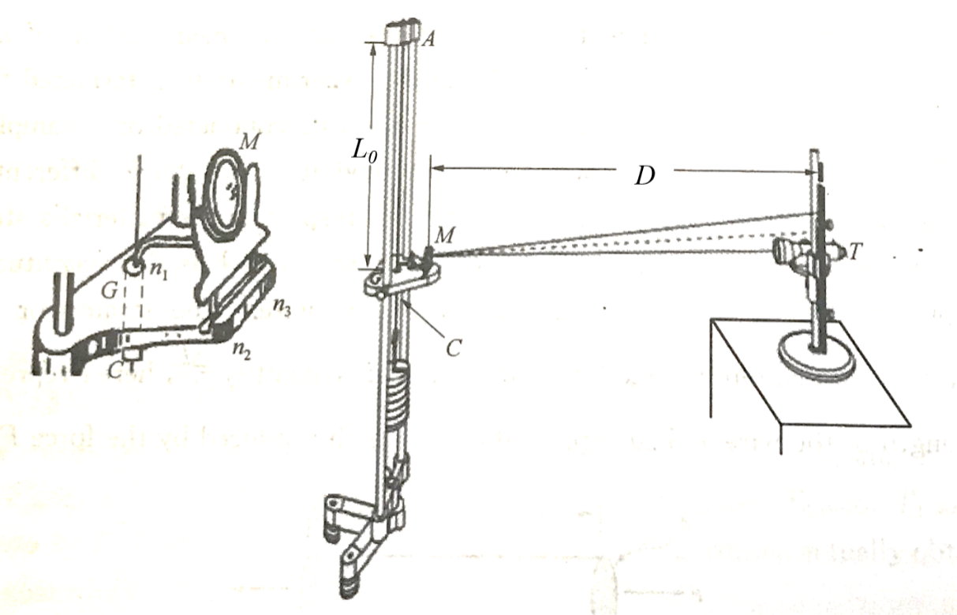

Fig. 2 Measuring Δ*L* by an optical lever. GC is the chunk, M is mirror: n1, n2 and n3 are three legs of the optical level: n1 is on the chuck while n2 and n3 ride in the groove of the small platform.

From Fig. 3, it is seen that the elongation **Δ*L*** is given by

 (3)

where ***b*** is the perpendicular distance of the mirror to the point on the chuck, or the perpendicular distance of n1 to the line of n2 and n3. By the motion of the mirror through the angle ***θ***, the reflected beam has therefore been turned through an angle **2*θ*** (based on the reflection law of light).

As a result, we get

 (4)

where ***D*** is the distance from the mirror to the scale,  is the scale reading before and after the applied weight, respectively. So, is the difference between the readings on the scale produced by the applied weight. Because *θ* is small so that . Equation (3), Equation (4) can be written as , and . Therefore,

 (5)

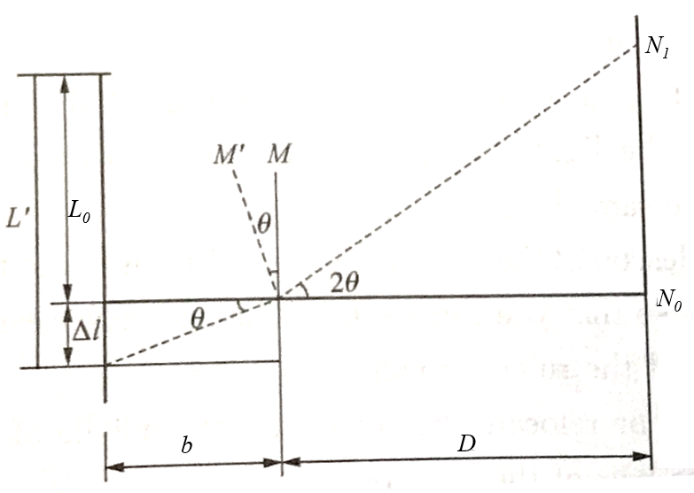

Fig. 3 The relationship between *D*, Δ*N* and Δ*L*

Due to the 2*D*>>*b*, so >>ΔL, the optical lever can enlarge the tiny length **Δ*L***, its magnification is *K* = 2*D*/*b*. Once you record the stress-strain diagram for the metal wire, and the slope of the graph of stress against strain, in the proportionality range (straight line portion of the graph) will give an experimental value for Young’s modulus.

**3. Procedure:**

**3.1 Aligning the System**

(a) Place the optical lever on the small platform of the tripod with setting the mirror vertically. Set the telescope and the reading scale at least 1 meter away from the mirror and at about the same height.

(b) Adjust the telescope (height and focus), so that you can see the reflected image of the measuring scale of the ruler through the mirror from the telescope clearly.

(c) Tilt the mirror or relocate the ruler until the middle of the scale of the ruler coincides with the cross-hair of the telescope.

**3.2 Determining Young's modulus**

(a) Carefully place 1kg on the weight hanger, keeping on hand under the weight hanger as each weight is added or removed lightly and carefully so that the image is not shifted by an unnecessary impact or vibration. Remember that 1 kg here is the mass for keeping the wire to be stretched. Do not count it as the first mass.  
 (b) Read ***N*0**, the position of the light spot reflected from measuring scale. Wait a minute until the reading shows little change.

(c) Add 1 kg more on the hanger, then read new ***N*1** at the new weight. Repeat this procedure until the weight of 7 kg is on the hanger.

(d) Remove 1 kg from the hanger, then read new ***N*1** at the reduced weight. Repeat this procedure until the weight of 7 kg is removed from the hanger.

(e) Fill all data in the following Table 3. Average these measured values to obtain the difference Δ*N* for each load.

(f) With the meter stick, measure the length of the wire between two chucks, and measure the distance ***D*** from the mirror to the reading scale.

(g) With the micrometer calipers, make five determinations of the diameter of the wire ***d*** (five different points along the length of the wire).

(h) With the ruler, measure the light lever constant ***b***.

**4. Data & Calculation:**

Table 1 Diameter of the steel wire Unit：mm

|  |  |  |  |
| --- | --- | --- | --- |
| Times | Zero reading *d*0 | Measured value *di* | Diameter of the wire *d* |
| 1 |  |  |  |
| 2 |  |  |
| 3 |  |  |
| 4 |  |  |
| 5 |  |  |
| Average diameter of the wire: , =**_________** | | | |

Table 2 Measure *L*0, *d*, *b*

|  |  |  |  |
| --- | --- | --- | --- |
|  | *L*0 (cm) | *D* (cm) | *b* (mm) |
| Single measurement |  |  |  |

Table 3 Data of stress against strain

|  |  |  |  |  |  |  |  |  |  |
| --- | --- | --- | --- | --- | --- | --- | --- | --- | --- |
| *M*(kg) | | 0 kg | 1 kg | 2 kg | 3 kg | 4 kg | 5 kg | 6 kg | 7 kg |
| *F*=*Mg* (N) | | / |  |  |  |  |  |  |  |
| **Stress**:  *F*/*A* (N/m2) | | / |  |  |  |  |  |  |  |
| *N*1 (cm) | Add weight |  |  |  |  |  |  |  |  |
| Reduce weight |  |  |  |  |  |  |  |  |
| Average  value |  |  |  |  |  |  |  |  |
| *N*1*-N*0 (cm) | | / |  |  |  |  |  |  |  |
| **Strain**: | | / |  |  |  |  |  |  |  |

**5. Results:**

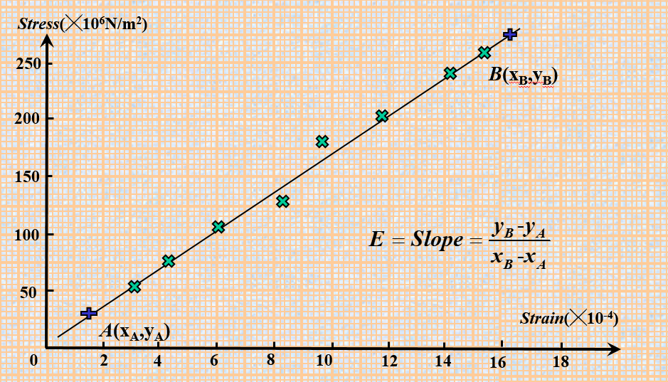

Fig. 4 Calculate the slope of the best-fit straight line based on the graphic method

Graphing the curve of the stress and stain to figure out the Young's modulus of the steel wire. An example is shown in Fig. 4.

(1) The stress is calculated as *F/A*, i.e., the applied weight divided by the cross-sectional area of the wire. The strain is calculated as Δ*L*/*L*0 *,* where *L*0is the length of the wire. Do these in Table 3, and be careful with units in calculations.

(2) Graphing the curve of the stress and stain. The slope of the stress-stain line is what we need for Young's modulus.

(3) Choose two points from the best-fitted line and calculate Young's modulus. Note that the two points are selected from the two side of the line and are not the measure points.

(4) Comparing with the typical Young's modulus value. Typical value: *E*steel＝1.80×1011 N/m2

**6. Conclusions:**

In no more than 100 words write a succinct summary of what you have done. State the goal and method of the experiment. State your main results, i.e.: What value did you get for Young’s Modulus? Is your result in agreement with the accepted value? If your result is not consistent with the accepted value can you suggest why not?

**Appendix: Telescope and reading scale**

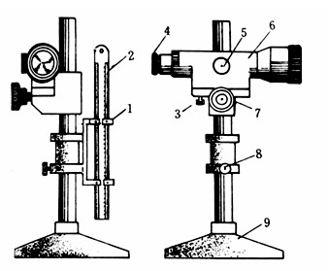

**1. reading scale; 2. reading scale fixture;**

**3. micro-knob; 4. eyepiece; 5. focusing knob;**

**6.** **telescope; 7, 8. [lock](javascript:;) [screw](javascript:;)s; 9. bottom support.**

## Experiment 5. Simple Harmonic Motion

**1. Aim:**

(a) To measure the spring constant of a spiral spring.

(b) To measure the period of oscillation of a spring and mass system and compare it to the theoretical value.

**2. Theory: (** **Read: Cutnell and Johnson – Chapter 10.1)**

In the absence of friction, a mass ‘***m***’ resting on a horizontal plane and attached to a spiral spring will, if disturbed from its equilibrium position, oscillate with a period ‘***T***’ given by:



where ‘***k***’ is the spring constant.

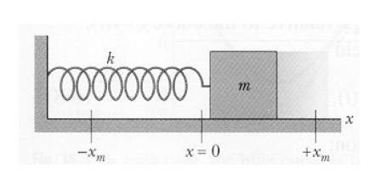

Hooke’s Law states that the force exerted by the spring is proportional to the distance from the equilibrium position (*x0*) and is directed towards that position:



where ‘***x***’ is the displacement from equilibrium (In the diagram above, ***xm*** represents the amplitude of the oscillations.) Thus the spring constant can be determined by applying varying forces to stretch the spring different distances. A plot of force versus distance will result in a straight-line graph of slope ‘***k***’.

**3. Procedure:**

PART 1 – Working out the spring constant.

(a) Weigh the cart and picket fence and record this value in your report. The air track has been setting level. Set up the air track and cart as shown Fig.1. Attach a string to the end of the cart and hang a mass hanger over the pulley.

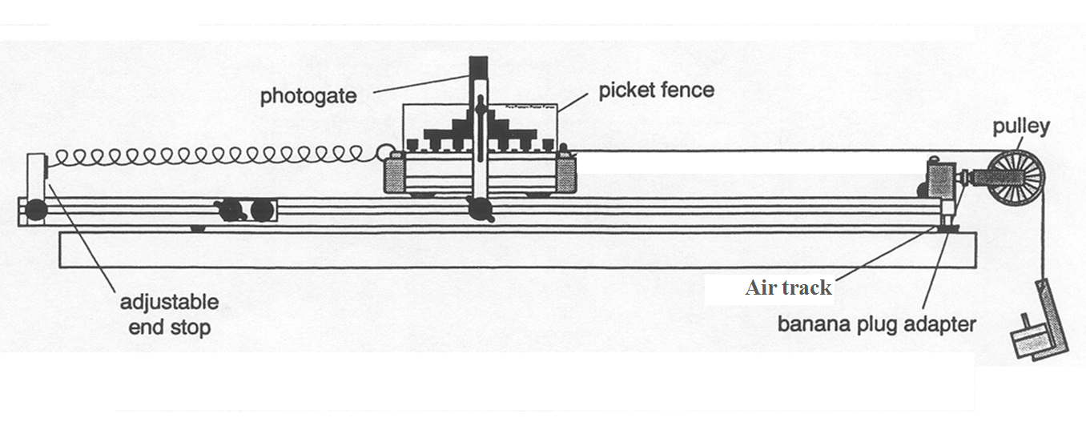

Fig.1 The instrument structure.

(b) Record the equilibrium position of the cart relative to the adjustable end stop. Add **12.6 g** progressively after each result, recording the cart's position in each case. Remember to calculate the total mass on the hanger in each case (mass of hanger + added masses). The displacement recorded is the distance from equilibrium.

Draw the following results table in your report.

Equilibrium Position = cm, Acceleration of gravity= **9.79 m/s2.**

Tab.1 Table of results.

|  |  |  |  |
| --- | --- | --- | --- |
| Mass on the Mass Hanger (×10-3kg) | Force on the Springs  *F* (×10-3N) | Position Relative to End Stop (cm) | Displacement *x* (cm) |
|  |  |  |  |
|  |  |  |  |
|  |  |  |  |
|  |  |  |  |
|  |  |  |  |

(c) Plot a graph of Force versus Displacement and calculate the slope of the best-fit straight line. This slope is the effective spring constant ‘***k***’ (N/m).

PART 2 – Measuring the experimental period.

(a) Set up the air track and cart as shown Fig.2. Position the photo-gate so that the **30.0 mm** flag on the picket fence will block the beam. Adjust the position of the gate so that this flag is centred on the beam.

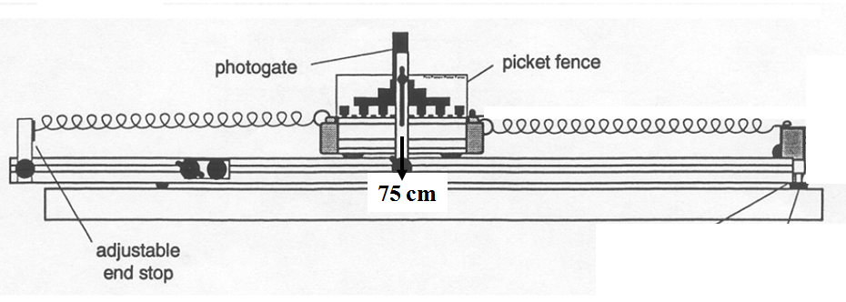

Fig.2 The schematic diagram of simple harmonic motion.

(b) Turn on the Smart Timer and pull the cart back a good distance and then release it. Once the cart has oscillated a few times the period will appear on the screen of the Smart Timer. Record this figure in your report.

(c) Add the **25.2 g** mass bar to the cart and repeat the measurement of the mean period.

(d) Calculate the percentage difference between the theoretical and experimental values of the period.

Draw the following results table in your report.

Tab.2 Table of Experimental Period.

|  |  |  |
| --- | --- | --- |
| Experimental period  *T* (ms) | Cart Alone | Cart with Mass |
| 1 |  |  |
| 2 |  |  |
| 3 |  |  |
| 4 |  |  |
| 5 |  |  |
| Average Time (ms) |  |  |

**4. Results:**

Plot ***F*** as a function of ***x***. Obtain an average value of ***F*/*x*** from the slope of the graph. When drawing the graph ensure that the points are evenly spread on both sides of the line.

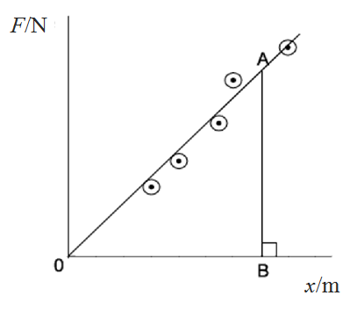

Fig. 3 How to get the slope.

A is any point on the graph and AB is perpendicular to the *x* axis.



**Calculate** ‘***k***’ from:



**5. Conclusions:**

Write a succinct summary of what you have done. State the goal and method of the experiment. State your main results, i.e., is the period of the oscillation correctly given by, within the experimental uncertainties?

## Appendix 1. Significant Figures

An important factor in the accuracy and precision of measurements involves the precision of the measuring tool. In general, a precise measuring tool is one that can measure values in very small increments. For example, a standard ruler can measure length to the nearest millimeter, while a caliper can measure length to the nearest 0.02 millimeter. The caliper is a more precise measuring tool because it can measure extremely small differences in length. The more precise the measuring tool, the more precise and accurate the measurements can be. When we express measured values, we can only list as many digits as we initially measured with our measuring tool. It should be noted that the last digit in a measured value has been estimated in some way by the person performing the measurement. For example, the person measuring the length of a stick with a ruler notices that the stick length seems to be somewhere in between 36 mm and 37 mm, and he or she must estimate the value of the last digit. Using the method of **significant figures**, the rule is that *the last digit written down in a measurement is the first digit with some uncertainty*. In order to determine the number of significant digits in a value, start with the first measured value at the left and count the number of digits through the last digit written on the right. For example, the measured value 36.7 mm has three digits, or significant figures. Significant figures indicate the precision of a measuring tool that was used to measure a value.

**Zeros**

Special consideration is given to zeros when counting significant figures. The zeros in 0.053 are not significant, because they are only placekeepers that locate the decimal point. There are two significant figures in 0.053. The zeros in 10.053 are not placekeepers but are significant—this number has five significant figures. The zeros in 1300 may or may not be significant depending on the style of writing numbers. They could mean the number is known to the last digit, or they could be placekeepers. So 1300 could have two, three, or four significant figures. (To avoid this ambiguity, write 1300 in scientific notation.) *Zeros are significant except when they serve only as placekeepers*.

**Example:**

Determine the number of significant figures in the following measurements:

a. 0.0009

b. 15,450.0

c. 6×103

d. 87.990

e. 30.42

**Solution**

(a) 1; the zeros in this number are placekeepers that indicate the decimal point

(b) 6; here, the zeros indicate that a measurement was made to the 0.1 decimal point, so the zeros are significant

(c) 1; the value 103 signifies the decimal place, not the number of measured values

(d) 5; the final zero indicates that a measurement was made to the 0.001 decimal point, so it is significant

(e) 4; any zeros located in between significant figures in a number are also significant

**Significant Figures in Calculations**

When combining measurements with different degrees of accuracy and precision, *the number of significant digits in the final answer can be no greater than the number of significant digits in the least precise measured value*. There are two different rules, one for multiplication and division and the other for addition and subtraction, as discussed below.

**1. For addition and subtraction:** *The answer can contain no more decimal places than the least precise measurement.* Suppose that you buy 7.56 kg of potatoes in a grocery store as measured with a scale with precision 0.01 kg. Then you drop off 6.052 kg of potatoes at your laboratory as measured by a scale with precision 0.001 kg. Finally, you go home and add 13.7 kg of potatoes as measured by a bathroom scale with precision 0.1 kg. How many kilograms of potatoes do you now have, and how many significant figures are appropriate in the answer? The mass is found by simple addition and subtraction:

7.56 kg - 6.052 kg + 13.7 kg = 15.208 kg = 15.2 kg.

Next, we identify the least precise measurement: 13.7 kg. This measurement is expressed to the 0.1 decimal place, so our final answer must also be expressed to the 0.1 decimal place. Thus, the answer is rounded to the tenths place, giving us 15.2 kg.

**2. For multiplication and division:** *The result should have the same number of significant figures as the quantity having the least significant figures entering into the calculation*. For example, the area of a circle can be calculated from its radius using *A* = *πr*2. Let us see how many significant figures the area has if the radius has only two—say, *r* = 1.2 m. Then, *A* = *πr*2 = (3.1415927...)×(1.2 m)2 = 4.5238934 m2 is what you would get using a calculator that has an eight-digit output. But because the radius has only two significant figures, it limits the calculated quantity to two significant figures or *A*=4.5 m2, even though *π* is good to at least eight digits.

## Appendix 2. Graphs

**Key Rules:**

1. Always use pencil when plotting graphs.

2. Label the axes and include appropriate units. By using powers of 10 the marks on the graph can be labelled 1, 2, 3….etc.

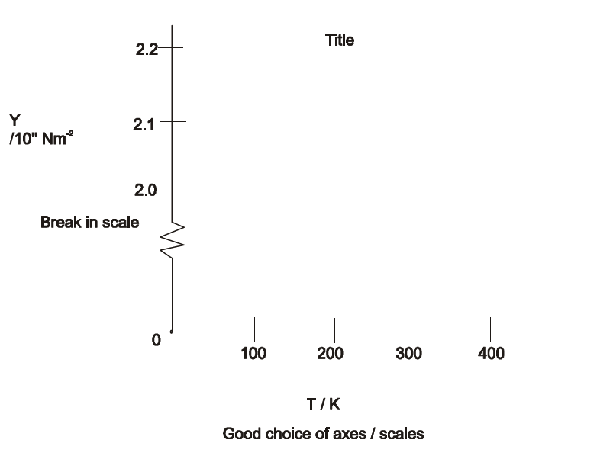

3. Choose the axes so that the points use the available space in a sensible way (show breaks in scale).

4. Title the graph.

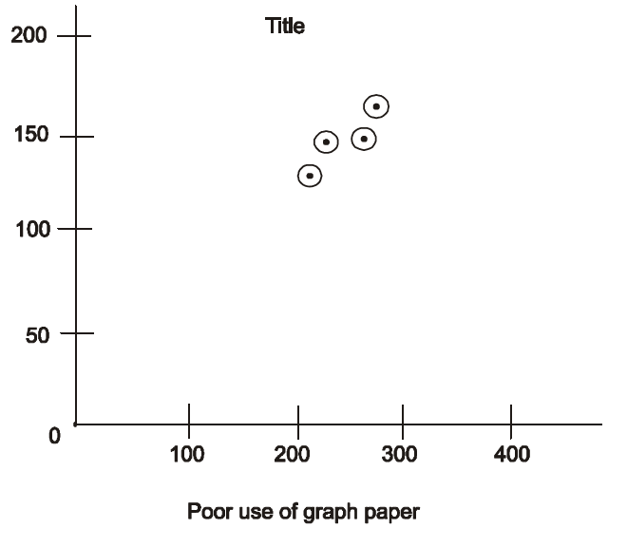

5. Plot points as dots surrounded by a small circle ‘’.

6. Draw the best straight line leaving the points spread evenly on both sides - do not make the graph go through the origin even if theoretically it should.

7. Take readings which are spread out evenly over the range of the quantity being measured.

8. Plot a graph as the experiment proceeds - check any points that seem widely off line. Plotting as the experiment proceeds also allows the distribution of points to be checked.

## Appendix 3. Uncertainties / Errors

Whenever a measurement is made, there is inevitably some uncertainty in its determined value. This uncertainty is often referred to as the ‘error’ on the measured value. Statistical methods have been developed for treating variations in experimental data. However, these will not be used in the present course. ‘Errors’ will be based on the limited accuracy of the laboratory instruments used in the experiments.

**The Calculus Method.**

The account of each experiment includes a section on error analysis. This suggests how the error on a calculated quantity should be worked out from the errors in the individually measured quantities on which the calculation depends e.g. in an experiment to determine the acceleration due to gravity ‘g’,



Here ‘g’ depends on the measured values of ‘L’ the length of the pendulum, and ‘T’ the period of oscillation.

There are a number of rules to calculating the errors this way. If a quantity A is calculated from the equation:



then the % error on A ( ΔA% ) is



It does not matter whether n, m or p are positive or negative, the % errors are always added.

Also n, m or p need not be whole numbers eg.  means .

Once the % error has been worked out on A, the actual error on A is calculated as:



The error on the individual items X, Y, Z etc. depend on the accuracy of the instrumentation eg. if X is a length ‘m’ measured with a metre stick whose accuracy is ±1 mm (10-3 m) then



Sometimes it is necessary to use a larger figure than the accuracy of the particular item of apparatus e.g. if a stop-clock with accuracy ±0.01 seconds is used to record an interval of time, the real error is the time taken to turn on and turn off the clock. This takes about 0.5 seconds, so ± 0.5 seconds would be a more reasonable measure of real accuracy.

In measuring the movement of a pointer along a scale two measurements are involved. If a metre stick is used each reading has an accuracy of ± 1 mm (10-3m). Hence the error on the difference in pointer positions is ± 2 mm (10-3m).

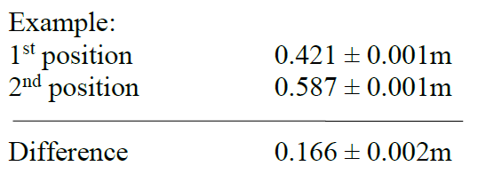

A similar approach is taken to calculating a change in temperature.

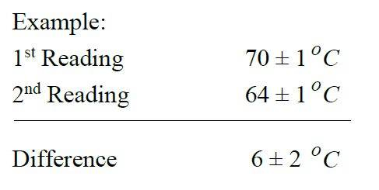

**The Error Range Method.**

The ‘Calculus’ method explained above is not suitable for complex equations.

e.g. 

The mean value of f (focal length) is calculated from a graph. To estimate the error choose typical values of d0 and di ; write these down including the error on each due to the experimental limitations i.e.



and



(where *d0*, *di* represent object and image distances respectively).

The **maximum value of *f*** within the errors Δ*d0* and Δ*di* is



assuming a real image i.e. *di* > 0

The **maximum value of *f*** is



again for a real image, *di* > 0.

Calculate Δ*f* , the error in *f*, as



**The Graphical Method.**

It is quite common to calculate a physical quantity from the slope of a straight line graph. This graph will have been plotted using experimentally measured values. A best fit will have been worked out with the points evenly distributed on both sides of this line. As explained in the section of the appendices on graphing, this ‘best fit’ should go through the ‘centroid’.

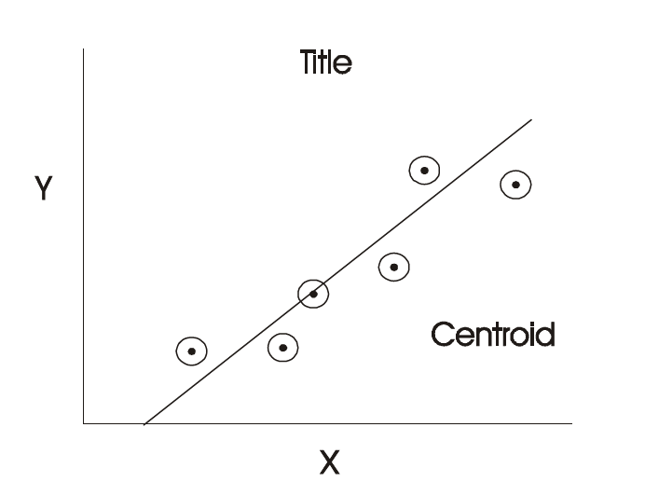

The equation of this graph is

*y = mx + c*

where ‘*m*’ is the slope and ‘*c*’ the Y intercept.

The graph can be used to estimate Δ*m* , the error in *m*.

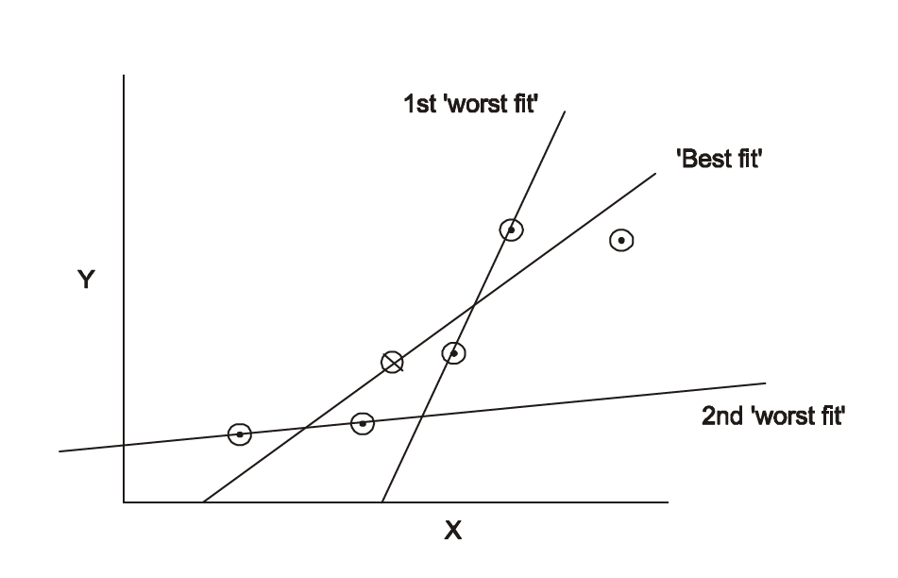

The ‘worst fit’ is the line through any two graph points which gives the greatest value for ‘m’ i.e which makes the largest angle with the X-axis. Assume m1 is the slope for the ‘best fit’ and m2 is the slope for the ‘worst fit’. An estimate for the error in *m* is



An alternative is to draw a second ‘worst fit’ line through two graph points which has the least slope i.e. a line which makes the smallest angle with the x-axis. If the slope of this line is m3, an estimate for the error in *m* is



## Appendix 4. The Vernier Calipers

A very ingenious device for obtaining accuracy of a greater order than that obtainable by eye-estimation was invented by P. Vernier (1580 - 1637), and is known by his name. In this device a small auxiliary scale is provided which slides along the ordinary scale. The divisions of this ‘vernier scale’ are either a little larger or a little smaller than the divisions of the main scale. The simplest arrangement is 10 vernier divisions equal 9 scale divisions. The Vernier Calipers is an instrument incorporating a ‘vernier scale’. The calipers provided is accurate to ±0.02 mm and can measure objects to 150 mm in size.

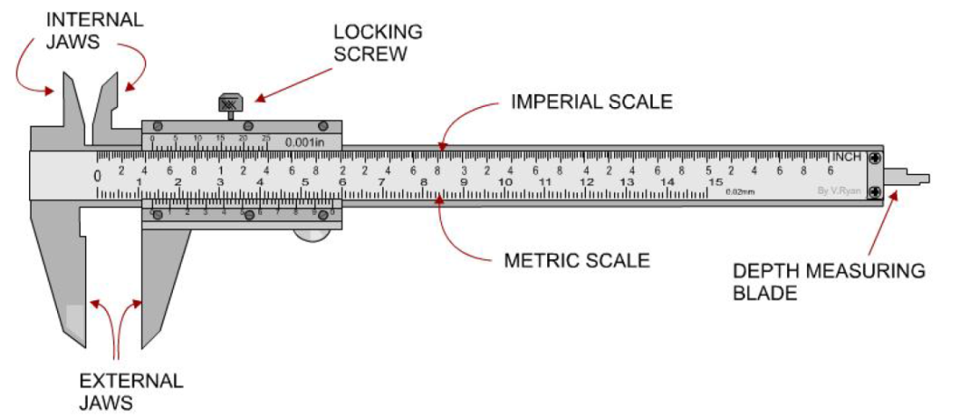

The lower or millimetre vernier scale is used in the laboratory. The scale is read as follows:

* Read and record (in millimetres) the figure on the main scale immediately preceding the zero of the vernier scale (A on diagram).
* Move along the vernier scale to locate a division that is directly in line with a division on the main scale. Record the position of this division on the ‘vernier scale’. Each small division of the vernier scale is 0.02 mm (B on diagram).

**Example:**

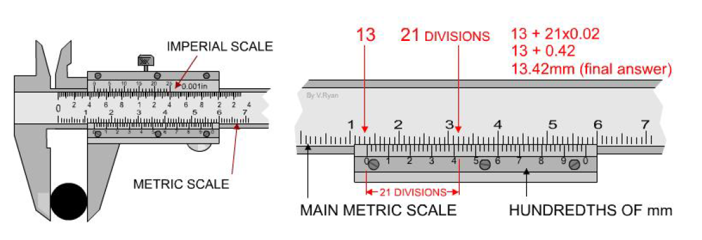

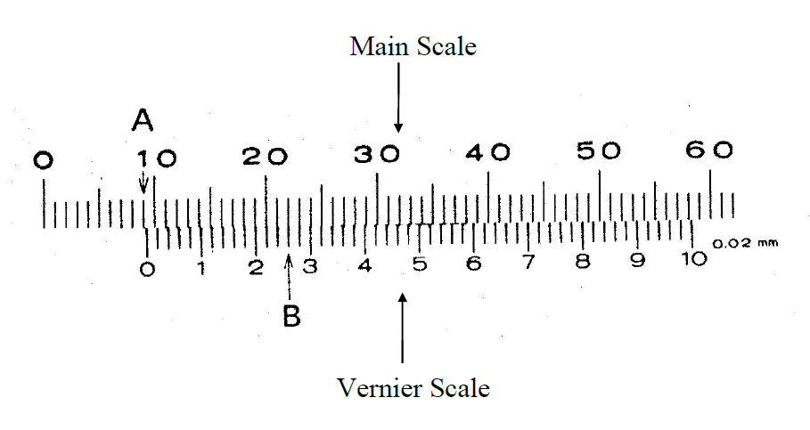

Reading A: 9 mm

Reading B: 0.26 mm

Total: 9.26 mm

Notice that ‘B’ represents thirteen 0.02mm divisions on the vernier scale.

## Appendix 5. The Micrometre Screw Gauge

The Micrometre Screw Gauge is an instrument which can measure accurately to ±0.001 mm. However, it is limited to objects less than 25 mm in size. This instrument also has a ‘vernier scale’.

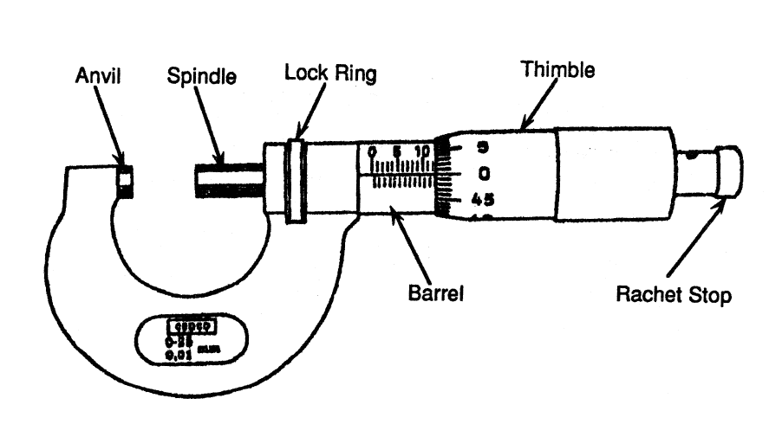

Close the micrometre fully using the ‘rachet stop’ (also known as the friction drive) to avoid over-tightening. Generally, the micrometre will not read zero and this ‘zero correction’ must be added to, or subtracted from the final reading as appropriate. Place the object to be measured between the ‘anvil’ and ‘spindle’. Tighten the micrometre using the ‘rachet stop’ (friction drive). An example is given below of how to read the micrometre. Adjust this reading for the ‘zero correction’.

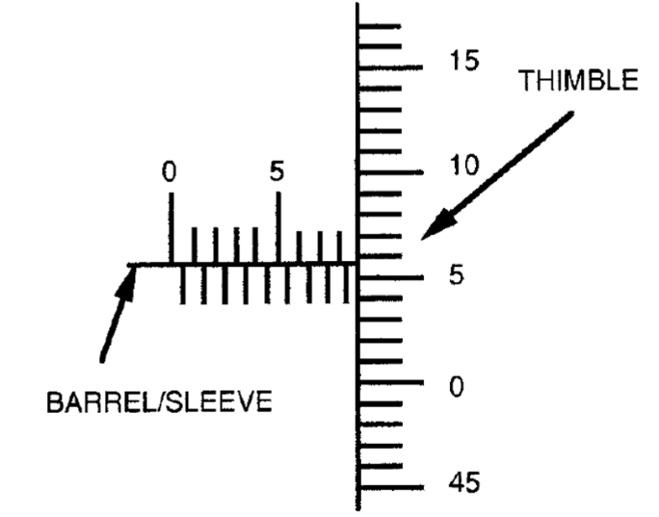

Read the barrel 8.500 mm

Read the thimble 0.058 mm

**8.558 mm**